Annual Conference of the
Austrian Studies Association

1914:
Preludes and Echoes
Auftakt und Widerhall

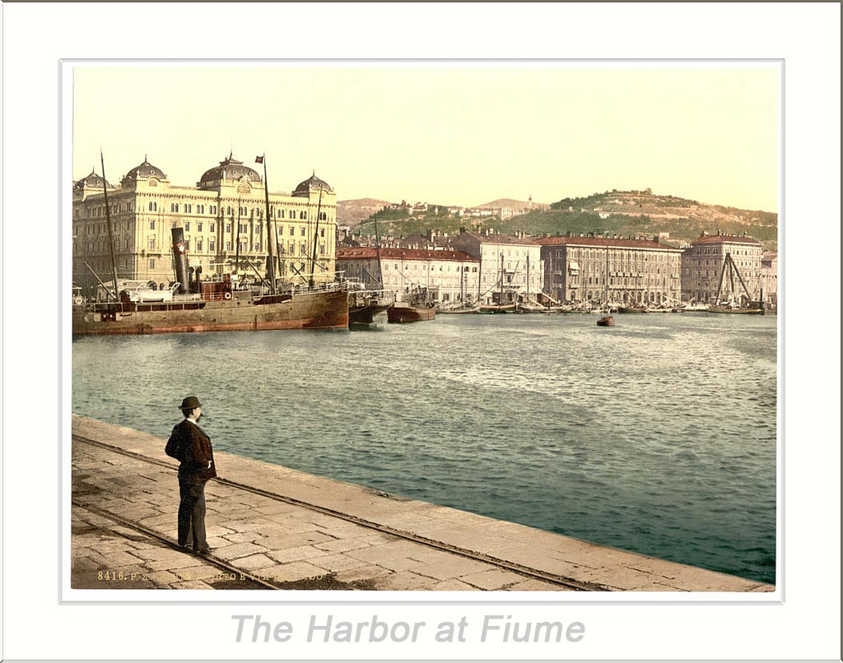

6-8 February 2014

AT&T Conference Center,
U of Texas at Austin

Littlefield Fountain
Part of the Littlefield Memorial Entrance Gate, a $250,000 gift of Maj. G. W. Littlefield. It was designed by Pompeo Coppini and arranged in place by consulting architect Paul P. Cret in 1932-1933. It consists of three concentric pools on different levels with jets of water spraying a bronze group, which represents Columbia returning victorious from World War I. In the wall back of the group, a bronze door leads to the pumps that drive the water. On the door is a dedicatory inscription to those "sons and daughters of the University of Texas" who gave their lives in World War I. < http://www.texasexes.org/uthistory/atoz.aspx?letter=L>
The inscription from Cicero reads, "Short life hath been given by Nature unto man; but the remembrance of a life laid down in a good cause endureth forever." < http://www.texasexes.org/uthistory/campus-tour.aspx?tourstop=0>

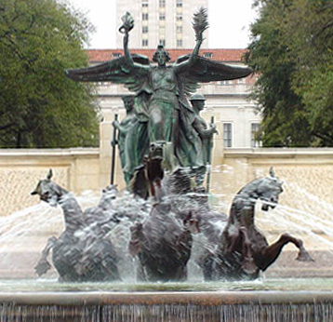
MAJOR SPONSORS FROM THE UNIVERSITY OF TEXAS AT AUSTIN
Center for European Studies

Department of Germanic Studies

Chair for Czech Studies, Department of
Slavic and Eurasian Studies

Other support:
Department of History
Austrian Studies Association

TRAVEL GRANTS:
Generous support for graduate student travel grants has been provided by the Austrian Cultural Forum, New York (www.acfny.org). Special thanks are due to its deputy director, Christian Ebner, for his work on the students' behalf

Additional support for graduate student travel has been provided by the Austrian Studies Association's own Jutta Landa Fund

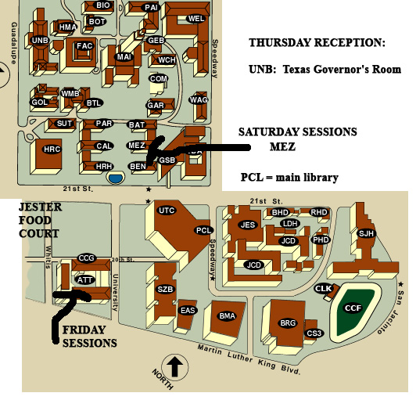

THURSDAY, 6 FEBRUARY

OPENING RECEPTION: 6-9 pm
Texas Union Governor's Room for registration and reception

Special presentation:

Jean M. Cannon,
UT Austin, Harry Ransom Humanities Research Center

"Curation and the Centenary: The Strategy of The World at War, 1914-1918"

7:30 PM: Texas Union Governors Room

RECEPTION compliments of the Center for European Studies

1

FRIDAY, 7 FEBRUARY
REGISTRATION: 8:00 on,
AT&T Center, Rooms 107 and 108 and hall in front of them

** Please note that there will be breakfast tacos available from 8-10:30 today-- so plan on breakfast at the conference.

FRIDAY: 9:00-10:15 AM, Sessions 1

ROOM 107:
PRELUDES 1914: THE WAR ARRIVES
Moderator: William H. Carter (Iowa State University)

Michael B. Barrett (The Citadel)
Romania’s Tortuous Entry into World War I

Robert Blobaum (West Virginia University)
War Comes to Warsaw, August 1914

Nathan N. Orgill (Georgia Gwinnett College)
The Public Echo: Public Opinion, the Press and Austro-German Decision Making in 1914

2
ROOM 108:
ECHOES: MEMORIALS
Moderator: Margarete Lamb-Faffelberger (Lafayette Coll.)
Karen Frostig (Lesley University and WRC, Brandeis U)
The Dream and the Nightmare: Waking Up from the Past
Paul Miller (McDaniel College, USA)
“The First Victim of the First World War”: Franz Ferdinand in Austrian History and Memory

Tim Corbett (Lancaster University)
Jewish and/or Austrian? The Matrix of Evolving Identities in Vienna’s Memorial to the Jewish Soldiers of the First World War

FRIDAY: 10:30-11:45, KEYNOTE OPENING

AT&T Center: Room 107
Keynote Speech:
David Luft
(History, Oregon State University)

“The Transformation of Austrian Intellectual Life: 1900-1938/1939.”

3
Opening remarks:
Robert Dassanowsky (U of Colorado, Colorado Springs), President, ASA

Christian Ebner, Austrian Cultural Forum
Moderator: Katie Arens, UT Austin

FRIDAY: 11:45-1:30: LUNCH BREAK

LUNCH ON YOUR OWN: you might visit the Blanton Museum (with a cafe) or the HRHRC (across the street from the Dobie Mall food court. See handout in your conference folder for other suggestions.

Austrian Studies Association Board Meeting for Officers and elected and ex officio Board members.
Please meet promptly in the hall outside the meeting rooms; we'll walk together to a private dining room (PDR 3) and the Carillon Restaurant's lunch buffet.

4

FRIDAY: 1:30-2:45 PM, Sessions 2

ROOM 107:
FILMING THE BRINK: STRATEGIC REPRESENTATIONS
Moderator: Sabine Hake, U of Texas at Austin

Joseph W. Moser (Randolph-Macon College)
Pre-WW I Austria-Hungary in Nazi Entertainment Film

Dagmar C. G. Lorenz (University of Illinois at Chicago)
The Cultural Break 1914—Continental and British Cross-Currents

Todd Herzog (University of Cincinnati)
Sex, Spies, and Videotape … and World War I

ROOM 108:
WW I REMAPPED: NEW HORIZONS FOR CONFLICT
Moderator: Karin Maxey (U of Texas at Austin)

Jason C. Engle (University of Southern Mississippi)
“Der letzter Aufgebot”: The Great War, the Standschützen, and the Alpine Tradition of War Volunteerism

Laura A. Detre (Randolph-Macon College)
Immigration, Anti-Semitism, and The Canadian Pacific Railway: The Case of Samuel Altmann
5
Mathieu Gotteland (University Paris I Panthéon-Sorbonne)
The Austro-Hungarian Concession in Tianjin [China] and World War One

FRIDAY: 3:00 - 4:15 PM, Sessions 3

ROOM 107
EXPERIMENTS: BEYOND HISTORICISM TO WITNESSING
Moderator: Matthias Falter (U of Vienna/ CAS Minneapolis)

Ulrich Bach (Texas State University)
“The curious alchemy of art”: On William Boyd’s Vienna

Theodore Fiedler (University of Kentucky)
Peter Handkes Slowenien

Anna Souchuk, DePaul University (Chicago)
Imprisonment, Sensationalism, and Austrian Vergangenheitsbewältigung: Marcus Schleinzer’s “Michael” and Linda Stift’s “Kein Einziger Tag”

ROOM 108
REVISITING AUSTRIAN HISTORY/IES
Moderator: Robert Dassanowsky (U of Colorado, CS)

Neil Christian Pages (Binghamton University SUNY)
Reading “1914” in Michael Haneke’s Das weiβe Band: Eine deutsche Kindergeschichte
6
Amanda Ziemba Randall, U of Texas at Austin
Austrian Trümmerfilm? What a Genre’s Absence Reveals about National Postwar Cinema and Society

Anita McChesney
Texas Tech University
Uncovering the Past in the Present: Fin-de-Siècle Austria in Lilian Faschinger’s Historical Novel Wiener Passion

FRIDAY: 4:25-5:30 PM, Sessions 4

ROOM 107
TEACHING WW I
Moderator: Per Urlaub (U of Texas at Austin)

Beret Norman (Boise State University)
“How not to teach the Beginning of World War I” or “Post and Tweet toward a more complex understanding of World War I’s Beginning”

Jennifer L. Good (Baylor University)
Practically teaching Kafka’s Amerika to Undergraduates: A Kafkaesque Challenge.

ROOM 108
AROUND STEFAN ZWEIG: LEGENDS OF THE FALL
Moderator: Marc Pierce (U of Texas at Austin)

Caroline Kita (Washington University in St. Louis)
Stefan Zweig's Jeremias in Exile
7
Ekaterina Kuznetsova and Natalia Tuliakova
(National Research University Higher School of Economics, Saint Petersburg)
Legende von Dritten Taube by Zweig: New Stage in the Development of the European Legend

Cynthia Klima (SUNY-Geneseo)
Wealth, Poverty and Society in Central Europe: An Analysis of the Works by Zweig, Leppin and Kosytolányi

FRIDAY PM: Evening on your own.

SATURDAY, 8 FEBRUARY:
Starting about 8:15:
Registration, coffee/tea, and light breakfast
MEZES HALL ROOM 1.104

SATURDAY, 9:00 - 10:45 AM, Sessions 5

Mezes 1.120
REPRESENTING THE AUSTRIAN-JEWISH EXPERIENCE
Moderator: Karl Ivan Solibakke (Syracuse University)

Hillary Herzog (University of Kentucky)
Gut und Blut For Kaiser and Fatherland: Jewish Identities in the First World War
8
Ashley Passmore (Texas A&M University)
Vienna, The War and Galician Jewish Memory: Y. L. Teler’s Yiddish Poetry

Helga Schreckenberger (University of Vermont)
Von Juden, Zuhältern und Prostituierten: Der Erste Weltkrieg in Abraham Mosche Fuchs’ Unter der Brücke
Ulrike Schneider (Universität Potsdam)
The Great War from German-Jewish Perspectives: The Experience of the War and the Encounter with other Cultural Systems

Mezes 1.102
MUSIC AT WAR
Moderator: Peter Hess (U of Texas at Austin)

Micaela Baranello (Princeton University)
Bombenerfolg: Karl Kraus and Die Csárdásfürstin at War

Michael Burri (University of Pennsylvania)
Austrian Cultural Missions after the First World War: Hugo von Hofmannsthal and Guido Adler

Michelle Duncan (Cornell University)
Freud’s Scriptural Rhetoric: Music, Noise, and Anti-Semitism

Simon Walsh (University of Michigan, Ann Arbor)
“Das Land der neuen Musik?“ Gert Jonke and New Music in Postwar Austria

9
Mezes 1.122
THE INTELLECTUALS' WARS
Moderator: Janet Swaffar (U of Texas at Austin)

John D. Pizer (Louisiana State University)
Disinclination/Appropriation/Poetization: Hofmannsthal’s Evolving Engagement with Poland and Polish Galicia before, during, and after the Great War

Birthe Hoffmann (University of Copenhagen)
Der Krieg als Symptom - Der Erste Weltkrieg in der Kulturkritik Robert Musils

Richard Lambert III (U of North Carolina/Duke U)
“The Great Experiment”: War and the Critique of Narrative in Hermann Broch’s Die Schlafwandler

Britta Kallin (Georgia Institute of Technology)
A Communist Interpretation of the Financial Crises of Capitalism: Elfriede Jelinek’s “Rein Gold” (2012)

SATURDAY: 11:00 AM-12:15 PM, Sessions 6

Mezes 1.120
‘‘The Streets of Vienna Are Paved with Culture, the Streets of Other Cities with Asphalt”: Museums and Material Culture in Austria
Moderator and Organizer: Julie M. Johnson, University of Texas at San Antonio
10
Reinhard Johler (University of Tübingen / Folk Arts Museums in Vienna)
Ethnographical Museums, World War I and the Presentation of Cultural Diversity

Anita Aigner (Technical University Vienna)
The Vienna Werkbund Estate on Display: Building Exhibition, Open-Air Museum, Digital Web-Exhibit

Diana Reynolds-Cordileone (Point Loma Nazarene University, San Diego CA.)
The case of Jelica Belovic: Political Radicalization and the Folk Arts in Bosnia 1896-1908

Mezes 1.102
TRAUMA, RECONSIDERED
Moderator: Cindy Walter-Gensler (U of Texas at Austin)

Heidi Schlipphacke (University of Illinois at Chicago)
Anticipatory Mourning and Melancholia: Freud’s Responses to War (1915)

Sabine Kock (Austrian Association of Independent Theater, Vienna)
Körperbilder und Liebeskonzepte zwischen revolutionär avantgardistischem Diskurs und faktischen Kriegsfolgen

Sharon Weiner (University of Illinois at Chicago)
Language and Trauma through a Wittgensteinian Lens in Ingeborg Bachmann’s Der Fall Franza

Mezes 1.122
THE WAR AND THE PRESS
Moderator: Jason E. Roberts (U of Texas at Austin)
11
Elisabeth Haid (University of Vienna)
"Die größte Schlacht der Weltgeschichte“: Austrian and Russian Press Reporting on the Battle of Galicia 1914

John E. Fahey (Purdue University)
The Guards Look Down: The KuK’s Views of Galicia 1890-1914

Primus-Heinz Kucher (Univ. of Klagenfurt/A):
"Die Russen kommen...“: Zu Hermann Blumenthals ethnographischen 'Kriegserzählungen‘ über die russische Offensive von 1914 in Galizien: Der Wall im Osten (1915)

SATURDAY: 12:15-1:30 PM :
Lunch on your own

SATURDAY: 1:30-2:45 PM, Sessions 7

Mezes 1.120
RETHINKING REPRESENTATION: FIGURES OF WAR AND EMPIRE
Moderator: Amanda Z. Randall (U of Texas at Austin)

Lorraine Markotic (University of Calgary)
"Reality, Representation, and 'Drommetenrot’ in Perutz’s Der Meister des Jüngsten Tages“

Ana Foteva (St. Lawrence University)
Karl Kraus’ Die letzten Tage der Menschheit: The Last Days of the Metaphor of Theatrum Mundi?
12
Imke Meyer
University of Illinois at Chicago
The Dialectic of Empire:
Franz Kafka’s “Beim Bau der chinesischen Mauer”

Mezes 1.102
AUSTRIAN POLITICAL SUBJECTS
Moderator: Kit Belgum (U of Texas at Austin)

John Deak (University of Notre Dame)
Austria in the First World War: The State of Exception

Matthias Falter (U of Vienna/CAS Minneapolis)
“Wir sind nun ein Volk”: Interpretations of the War and the (Re-)Construction of Political Community in Austrian Parliamentary Debates 1918-1919

Felix Tweraser (University of West Georgia in Carrollton)
"In Schlachten und Siegen hat er geschwiegen:" Arthur Schnitzler's Anti-War Writings and the Composition of "Casanovas Heimfahrt" (1917)

Mezes 1.122
HISTORIES (ALT)?
Moderator: Martin Baeumel (U of Texas at Austin)

Sophia Clark (Vanderbilt University)
German Nationalism and the Austrian Fantastic - Two Paths: Strobl and Meyrink

Katherine Sorrels (University of Cincinnati)
An Aristocracy of Spirit not Blood: Reimagining Habsburg Aristocracy after the First World War

13
Martin Modlinger (Universität Bremen)
Civilization… is it really worth the trouble? Klaus Ebner’s Hominide

SATURDAY: 3:00-4:15 PM, Sessions 8

Mezes 1.120
AESTHETIC APPROPRIATIONS OF WAR EXPERIENCE
Moderator: Felix Tweraser (U of W Georgia in Carrollton)

Pamela Sewell Saur (Lamar University [Beaumont, TX])
Expressionistic World War I Poetry by Ernst Weiss and Anton Wildgans

Sonja Niederacher (Bundesministerium für Unterricht, Kunst und Kultur / Leopold Museum Privatstiftung, Wien)
Egon Schiele im Ersten Weltkrieg

Lina Užukauskaitė (Universität Salzburg/ Vytautas Magnus Universität Kaunas)
"Der Krieg ist schön“ (Filippo Tommaso Marinetti): Ingeborg Bachmanns Widerspruch

14
Mezes 1.102
AUSTRIA AT WORK, AUSTRIA IN NEED
Moderator: Cori Crane (U of Texas at Austin)

Sarah Painitz (Butler University in Indianapolis)
Women at Work: Occupational and Social Change in Austria after the First World War

John Robertson (U of North Carolina at Chapel Hill)
Calamitous Methods of Compulsion: The Ostrava-Karviná Strike Wave of 1916

SATURDAY: 4:15 PM
Mezes 1.122
Note: Event for invited participants only

Todd Herzog and Hillary Herzog, presiding
Board Meeting for The Journal of Austrian Studies

15

SATURDAY: 6:30 ff.
BANQUET and business meeting

Scholz Garden
http://www.scholzgarten.net/

The restaurant is a 10 or so minute walk from the AT&T Center.
Exit the AT&T Center and go south to MLK Street. Turn left (east, downhill) on MLK and walk 3 blocks to San Jacinto Street. Turn right (south) onto San Jacinto for two blocks. Scholz' is at SJ and 17th. Enter off of 17th Street directly into the Banquet Hall, but don't miss the heritage building off of SJ! The "Sängerrunde Hall" that is one of Austin's oldest continuous establishments.

BUSINESS MEETING:
Robert Dassanowsky, presiding

Includes:
- Announcement of ACNY and Jutta Landa Travel Grants
- Announcement of JAS / Max Kade Institute Article Prize
- Announcement of new Honorary Members for the Austrian Studies Association
- Information on next conference

16

